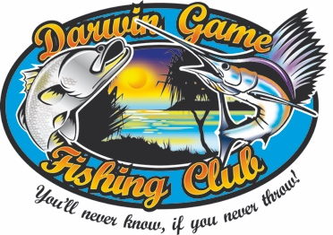DUNDEE BILLFISH BASH 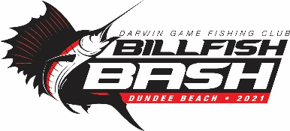
10 - 11 APRIL 2021
ENTRY FORM

Entries should be sent to brucesaz@westnet.com.au
Entry $40 per adult and $20 per junior (under 16 as at 10th April 2021)
Family Entry $100 (covers 2 adults and all children)

Team Name (if known)…………………………………………………………

Skipper:……………………………………………………………… Adult F/ Adult M / Junior / DGFC Member

Team member.................................................... ………………. Adult F/ Adult M / Junior / DGFC Member

Team member………………………………………………………. Adult F/ Adult M / Junior / DGFC Member

Team member……………………………………………………… Adult F/ Adult M / Junior / DGFC Member

Team member……………………………………………………... Adult F/ Adult M / Junior / DGFC Member

Team member……………………………………………………… Adult F/ Adult M / Junior / DGFC Member

Team member……………………………………………………… Adult F/ Adult M / Junior / DGFC Member

Skipper Contact information:

Phone No………………………………………………………….

Email………………………………………………………………..

Boat Details (Name, Make, Size and Side on Photo Attached)………………………………………………….

Type of Boat (cabin, centre console, etc) ……………………………………...……..

VHF on Board: Yes / No Required Safety Equipment Yes / No

I, …………………………………………………….(skipper) agree that I will follow the rules and decision of the Darwin Game Fishing Club for this competition and that I accept responsibility for the safety of my team members. I will include a side on picture of my vessel included with my entry to assist in the unlikely event of an emergency.

……………………………………………………………….. Date………………………
Signature

Entry fees can be made via direct deposit to Darwin Game Fishing Club using your last name as the reference.
BSB: 633 000
Acc:1554 20466

